25. Variation and Microevolution (3) (*RHM: Chapter 21*)

______________________________________________________________________________

XII. Natural Selection *(486-490)*

A. Definition and Action

B. Selection on Polygenic Characters

1. Stabilizing (= balancing) selection

2. Directional selection

3. Diversifying (= disruptive) selection

XIII. Genetic Drift *(485-486)*

A. Definition

B. When is Chance Important in Evolution?

C. Effects of Genetic Drift

D. Ecological Circumstances Promoting Genetic Drift

XIV. What Maintains Variability in Natural Populations? *(471-475)*

A. Single Gene Heterosis

B. Selection for Heterozygosity

C. Selection in Variable Environments

D. Non‑Darwinian Explanations

25-1

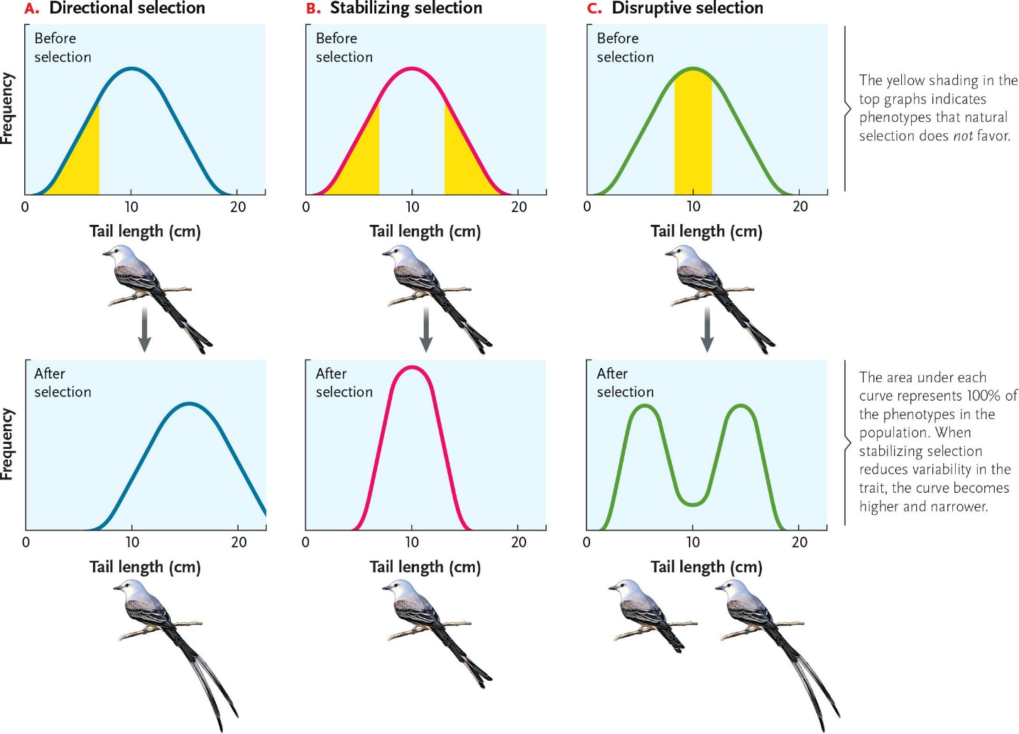

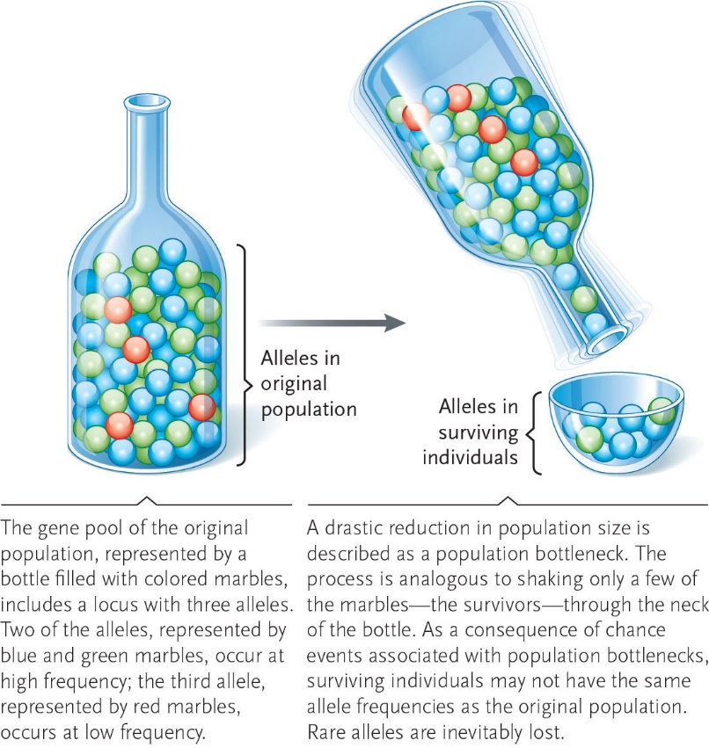

25-2

